[Type the company address]

2012

HefnyCopter2

User Guide

M.Hefny

[Type the company name]

Contents

# What is HefnyCopter2?

[HefnyCopter2](http://code.google.com/p/hefnycopter/) is a firmware system designed for QuadCopters to work on [KK2 control board](http://www.hobbyking.com/hobbyking/store/__24723__Hobbyking_KK2_0_Multi_rotor_LCD_Flight_Control_Board.html).

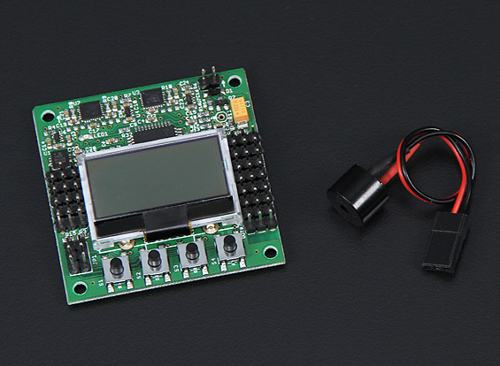

Figure : KK2 Control Board

# Features

* **X and + Mode:** You can switch modes between X Quad & +Quad without the need to change board orientation or upload a different software. You can simply use TX sticks to switch between these modes or LCD. This is a main feature for HefnyCopter firmware. The board does not save your latest choice. You have to set it each time you start it up. The default is Plus configuration.
* **Smart RX wiring:** Instead of wiring five connections from RX to the board, RX board pin order are removed from [AIL, ELE, THR, RUD, AUX] to [AIL, ELE, THR, RUD, AUX]. That means you need only one cable to connect AIL, ELE & THR. That means less wires around the board.
* **UART1 TX & RX:** You can use Motor [5,6,7,8] pins as RX signals. This allows you to use UART1 for sending and receiving data.
* **Buddy Control RX:** HefnyCopter allows you to connect two RX to your quadcopter. This allows you to train your friend or your son without taking risk of crashing your quadcopter. In BuddyControl mode you can use the AUX to switch control between you and your buddy. In buddy mode you cannot arm your quad unless both RX signals are ok.   
  Please refer “Wiring Connections for Extreme Configuration” to know proper connections.
* **New Stabilization System:** HefnyCopter2 implements an enhanced PID algorithm. The KK2 board contains ACC & GYRO that much better stability. Please refer to videos in the useful links for a [demo](http://www.youtube.com/watch?v=BknlTkF9ZOQ) .
* **Auto Disarming:** When leaving throttle stick down without disarming, your quad will wait for a certain time then disarm itself as a safety procedure. You can control this period from Misc menu or disable it by setting value to 0 based on your preference. Also whenever you press a button while the board is armed it disarms itself.
* **Altitude Change Limit:** This uses the accelerometer Z-axis to monitor gravity. Whenever there is a sudden change in altitude the firmware smooths this change. This is very useful to avoid aggressive falling down.
* **Long Range for PWM Signal:** some firmware use a range from 0 to 200 to represents from 0 to full throttle. That means you have only 200 steps of power adjusting. Usually this implies using 25% of it for balancing which means 50 steps only. HefnyCopter2 software uses a range from 0 to 1000, and a balancing value up to 300. This provides more accurate info for ESC to respond.
* **Lost Buzzer:** if at any time the signal was lost while motors are running buzzer works to help you to know your Quadcoper location[1].
* **Sticks as Buttons:** Sometimes your buttons will be hard to access because of wires or a plastic cover. Sticks can be used as buttons for changing settings in the field fast. Please note that only RX-2 can be used as button, as it is the main RX.

# Know Your Board

HobbyKing KK2.0 Control Board is a big step forward from its [predecessor](http://www.hobbyking.com/hobbyking/store/__19534__HobbyKing_Multi_Rotor_Control_Board_V2_1_Atmega168PA_.html), the board contains

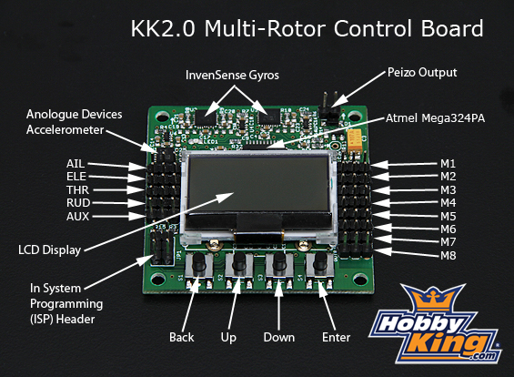

Figure : KK2 Board Layout from HobbyKing.com

**Board Hardware Specifications:**

Size: **50.5mm x 50.5mm x 12mm**  
Weight: **21 gram (Inc Piezo buzzer)**  
IC: **Atmega324 PA**  
Gyro: **InvenSense Inc.**  
Accelerometer: **Anologue Devices Inc.**  
Input Voltage: **4.8-6.0V**  
AVR interface: **standard 6 pin.**  
Signal from Receiver: **1520us (5 channels)**LCD Display: **128 x 64 pixels.**

The main features here are the new accelerometer sensors besides the gyro, also the LCD & Buzzer. LCD opens new possibilities of adjusting different parameters and modes using UI instead of using old POTS and to adjust previous board. Life is a lot easier now.

# Setting-Up your Board

***“It is strongly recommended to take off propellers before setting up your board at least especially for the first time. Although there is some safety internal code for known scenarios, however it does cover all possible scenarios.”***

## Step #1 - Connecting Your Board

1. 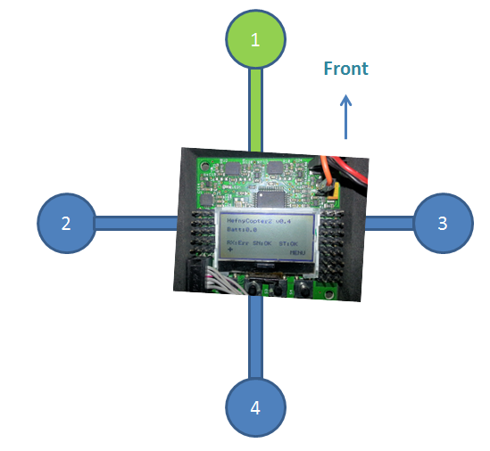Put the board with the right orientation. The LCD screen top should be perpendicular to your front motor as in below figure. This orientation is fixed either you choose to fly in X-mode or Plus-mode.

Figure : Board Orientation

1. Connect ESC motors in order M1,M3,M4,M2 clockwise where M1 is your front motor.
2. 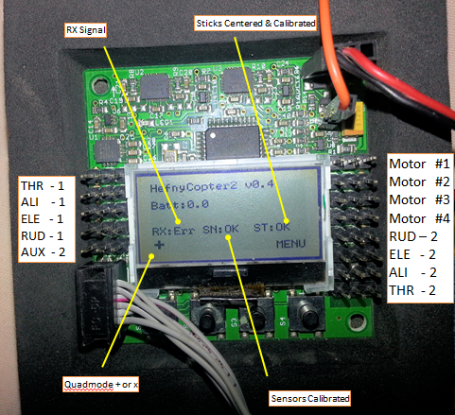Connect your Primary Receiver to pins RUD2 – ELE2 – ALI2 – THR2. These are the pins originally known as M5,M6,M7,M8

Figure : Wiring Connections for Extreme Configuration

For now do not connect your Secondary Receiver, we need to adjust other stuff first.

## Step #2 – Stick Centering

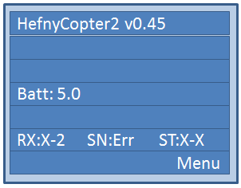

1. Turn-on Transmitter.
2. Whenever you make calibration make sure that TX trims are all ZEROs.
3. Turn-on Board.

If you never calibrated your receiver before you should find on LCD “ST:X-X” which refers to stick calibration.

1. Use buttons on board to navigate to “Stick Calibration”.

You can use this screen to calibrate primary & secondary receivers in buddy mode.

1. Now move sticks up & down, left & right. Moving speed is not a factor, but you need to leave the stick for a second or two on each direction.
2. The AUX channel should be toggled as well. You can connect it to switch or tri-switch as you wish.
3. Press Continue and you will hear a long beep. If you hear three short beeps then there is an error. That means you forgot to move one of the sticks or one of channels are not activate so check wiring.
4. After successful calibration, you may press back to go to main menu.

* ***AUX channel is something for Primary RX only. For Secondary TX just ignore it.***

## Step #2 – Sensor Calibration



1. Turn-on Transmitter.
2. Turn-on Board.

If you never calibrated sensors before you should find on LCD “SN:Err” which refers to sensor status.

1. Put your Quadcopter on a flat horizontal surface.
2. Navigate to “Sensor Calibration”
3. Press Continue. Once you hear the beep you can press back.
4. The homepage now should have “SN:OK”

You may repeat this operation as much as you want.

# Arming & DisArming

Use sticks as in the below image to ARM & DISARM your quad.

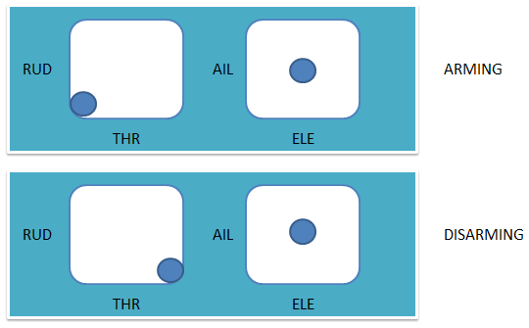

Figure : Arming & Disarming Quadcopter

Please use that AutoDisarm is also valid and recommended for your own safty. It can be adjusted from MISC. menu. Quad goes to AutoDisarm when throttle stick is below minimum i.e. motors are off for sometime that can be adjusted by you.

Also if you touch any button on the board while quadcopter is armed it will disarm itself as a safety procedure. This feature cannot be disabled.

# Flying Configuration

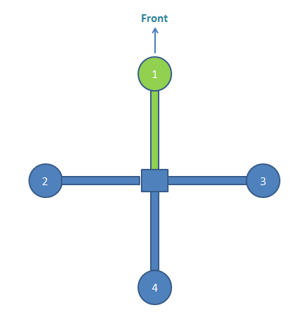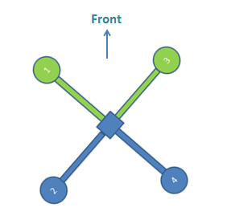HefnyCopter2 supports Quadcopter only. It has the advantage of switching flying configuration without the need to change board orientation or change firmware or wiring.

Figure : Plus Configuration

Figure : X-Copter Configuration

To switch between these modes you first need to disarm your Quadcopter and then use sticks as in below images to select between different modes.

Please note from above images the X front direction is the M1 and M3 which is the motor on the right.

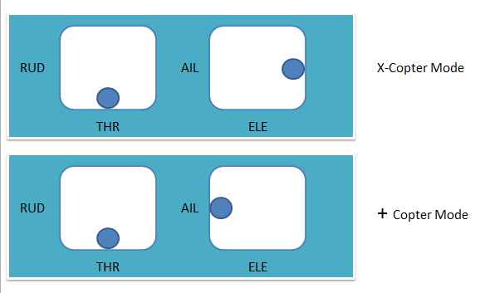

Figure : Changing Quadcopter modes

You can also refer to this video <http://www.youtube.com/watch?v=55Ab4BfcQss>

This is a demo for how to change between different modes it was developed for HefnyCopter and still the same technique is used in HefnyCopter2.

# Using Sticks as Buttons

First you have to disarm your quadcopter, then move throttle high to maximum. ELE & ALI can be used and the four buttons. They are fast and easy.

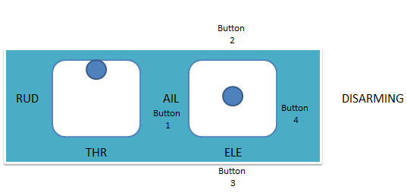This feature is not active until Stick Centered and Calibrated. This feature also should be enabled from MISC menu.

TroubleShotting

Please check update list in

# Useful Links

1. HefnyCopter2 Downloads  
   <http://code.google.com/p/hefnycopter/downloads/list>
2. QuadCopter Modes Setup using TX Sticks  
   <http://www.youtube.com/watch?v=EGGT-8hfLR8>
3. XQuad and +Quad Video  
   <http://www.youtube.com/watch?v=55Ab4BfcQss>
4. Stabilization Test of HefnyCopter2  
   <http://www.youtube.com/watch?v=Kb-f4SKA6Bs>  
   <http://www.youtube.com/watch?v=BknlTkF9ZOQ>

1. It is very possible to have your Quadcoper broken and the board is no longer working because of direct damage or battery disconnection. Still there is a big chance that the board survives and the beep helps you to know where it is.